150
0
50
100
10
20
30
40
50
60
70
0
80
90
100
Eating a bar of chocolate
Mass of chocolate (g)
Time (seconds)

0
1300
1400
1500
10
20
30
40
50
x
1600
C
D
B
A
60
E
F

The graph shows a cars journey.

- When is the car halfway between A and B ?
- Between what times does the car stop at D to E?
- When the care is halfway between C and D on the return journey?
- Find the speed of the car
i) From A to B
ii) From C back to D
iii) From E back to F

Copy the following graph.
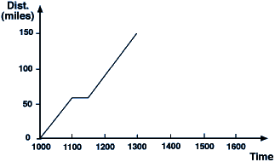
The Smith family are to drive 150 miles to a holiday cottage. They stopped to fill up with petrol on the way there. The graph above shows their distance from home against time for their journey.
(a). When did they stop for petrol and for how long? [2 marks]
(b). Calculate their average speed for the journey. (don't count stoppage time) [3 marks]
(c). Half an hour after they arrive at the cottage they discover that they have left the keys for the cottage at home. Show this time on the graph. [1 mark]
(d). The journey home was completed at an average speed of 50 m.p.h. (while on the move) but they were delayed for 15 minutes behind a tractor. Complete the graph to show the rest of the journey home and state when they arrived home. [4 marks]

